Preparation of Papers for International Journal of Trade, Economics and Finance (IJTEF)
First A. Author*, Second B. Author, and Third C. Author
¹Department, Faculty, University, City, Country
²Department, Faculty, University, City, Country
Email: first.author@hostname1.org (F.A.L.); second.author@hostname2.org (F.B.L.); third.author@hostname2.org (F.C.L.)
*Corresponding author
Manuscript received July 19, 2024; revised August 2, 2024; accepted August 21, 2024; published 2024.

Abstract—These instructions give you guidelines for preparing papers for the International Journal of Trade, Economics and Finance (IJTEF). Use this document as a template if you are using Microsoft Word 6.0 or later. Otherwise, use this document as an instruction set. The electronic file of your paper will be formatted further at IJTEF. Define all symbols used in the abstract. Do not cite references in the abstract. Do not delete the blank line immediately above the abstract; it sets the footnote at the bottom of this column.

Keywords—first term, second term, third term, fourth term, fifth term, sixth term, seventh term

Introduction
A well-written introduction will provide your study with a context and prompt the readers to read the rest of your paper. This section should briefly place the study in a broad context and highlight why it is important. It should define the purpose of the work and its significance. In this section, authors should briefly highlight the main developments of their research topic and identify the main gaps that need to be addressed. In other words, this section should give an overview of your study. The section should be organized as:
- What is known about the broad topic?
- What are the gaps or missing links that need to be addressed?
- What is the significance of addressing those gaps?
The introduction should provide general information about the topic of your research and emphasize the main aims of the study. Please ensure that you only discuss the main and relevant aspects of the studies that have led to your aims. Do not elaborate on them as this should be done in the literature review section.

Literature Review
This section basically supports the background section by providing evidence for the proposed hypothesis. This section should be more comprehensive and thoroughly describe all the studies that you have mentioned in the background section. It should also elaborate on all studies that form evidence for the present study and discuss the current trends.
To write this section, you will need to do a thorough literature search on different studies that relate to the broad topic of your research. This will introduce the readers to the area of your research. It would be ideal to organize them thematically and discuss them chronologically so that readers are aware of the evolution and progress in the field. In other words, separate themes should be discussed chronologically to highlight how research in those fields has progressed over time. This will highlight what has been done and what are the future directions that need to be worked upon.

Materials and Methods
A well-scripted methods section lays the foundation for your research by outlining the different methods you used to derive your results. The methods used to achieve the objectives must be described precisely and in sufficient detail, so as to allow a competent reader to repeat the work done by the author.
Numbered lists can be added as follows:
- First item;
- Second item;
- Third item.
Bulleted lists look like this:
- First bullet;
- Second bullet;
- Third bullet.

Result and Discussion
A well-presented results section coupled with a convincing discussion will definitely prove the novelty and importance of your study. It should provide a concise and precise description of the experimental results, their interpretation, as well as the experimental conclusions that can be drawn.

Figures and Tables (Subsection Level 2)
Figures and tables should be inserted in the main text in continuous order and should be called out, e.g., Fig. 1 and Table 1. Large figures and tables may span across both columns. Figure captions should be centered below the figures; table captions should be centered above. Avoid placing figures and tables before their first mention in the text. Use the abbreviation “Fig. 1,” even at the beginning of a sentence.

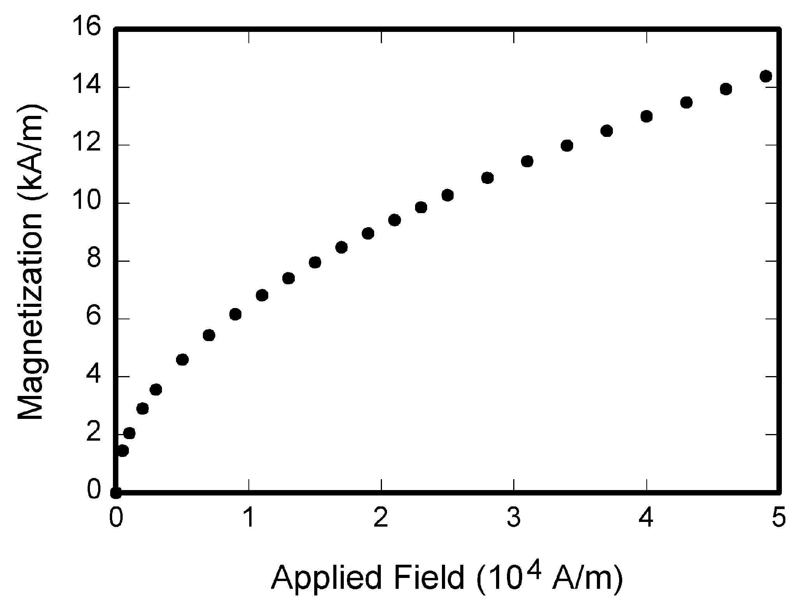
Fig. 1. Magnetization as a function of applied field.

For figure axis labels, use words rather than symbols. Do not label axes only with units. Do not label axes with a ratio of quantities and units.

Table 1. The arrangement of channels
Channels | Group 1 | Group 2 | … | Group c
Main channel¹ | Channel 1 | Channel 2 | … | Channel c
Assistant channel | Channel 2 | Channel 3 | … | Channel 1
¹ Tables may have a footer.

Subsection (Level 3)
Here is the content of Subsection (Level 3).

Subsection (Level 4)
Here is the content of Subsection (Level 4).

Citations
These are your in-text, in parentheses, identifications of other research. Every work that has a citation needs to have a corresponding reference (see “References,” below). Examples:
Name and year—Several studies (Adams, 1994; Bernstein, 1988, 1992; Celias, 2000a, 2000b) support this conclusion.
Year only—But Van Dorn and Xavier (2001) presented conflicting evidence
Order. Order citations alphabetically. Designate two or more works by one author (or by an identical group of authors) published in the same year by adding “a,” “b,” and so forth, after the year. See the “name and year” example above.
Multiple authors. If a work has two authors, give both names every time you cite it. For three through six authors, give all names the first time, then use “et al.” in citations. Examples:
First citation—(Foster, Whittington, Tucker, Horner, Hubbard, & Grimm, 2000).
Subsequent citation—(Foster et al., 2000).
For seven or more authors, use “et al.” even for the first citation. (But the corresponding reference should give all the names.)
Electronic sources. Use a regular citation (author, year) if you can identify an author of one of the types discussed above (human, periodical, or corporate). If not, give the web address that was your source in parentheses. No corresponding reference need be used in the latter case.

References
If you are using EndNote, download the Academy of Management Journal Style from the EndNote Styles page: https://endnote.com/style_download/academy-of-management-journal/
References are your entries in the alphabetical list at the end of your article or research note. This list should include only work you have cited.
Alphabetize references by the last name of a sole author, a first author, or an editor, or by the name of a corporate author (for instance, U.S. Census Bureau) or periodical (such as the Wall Street Journal) if there is no human author or editor. Order works by an identical author by year of publication, listing the earliest first. If the years of publication are also the same, differentiate entries by adding small letters (“a,” “b,” etc.) after the years. Repeat the author’s name for each entry.
Each reference appears on a new line. There is no numbering of the references. Use single line spacing with a double line of space between references. Each reference should be presented with a hanging indent, that is, indent the second and subsequent lines of the reference by two characters space.

Abbreviations and Acronyms
Define abbreviations and acronyms the first time they are used in the text, even after they have already been defined in the abstract. Abbreviations such as SI, ac, and dc do not have to be defined. Abbreviations that incorporate periods should not have spaces: write “C.N.R.S.,” not “C. N. R. S.” Do not use abbreviations in the title unless they are unavoidable (for example, “JOURNAL OF ECONOMICS, BUSINESS AND MANAGEMENT” in the title of this article).

Equations
Number equations consecutively with equation numbers in parentheses flush with the right margin, as in Eq. (1). First use the equation editor to create the equation. Then select the “Equation” markup style. Press the tab key and write the equation number in parentheses. To make your equations more compact, you may use the solidus ( / ), the exp function, or appropriate exponents. Use parentheses to avoid ambiguities in denominators. Punctuate equations when they are part of a sentence, as in
$\begin{aligned}\int{ F(r,ϕ)} \text{dr} dϕ=[{σr}_{2} (2μ_{0})] \\ ⋅ \int{ \text{exp}}(−λ|z_{j}−z_{i}| ) λ^{−1} J_{1}(λ r_{2}) J_{0}(λ r_{i}) dλ \text{.}\end{aligned}$ (1)
Be sure that the symbols in your equation have been defined before the equation appears or immediately following. Italicize symbols (T might refer to temperature, but T is the unit tesla). Refer to “Eq. (1),” not “(1)” or “equation (1)”.

Other Recommendations
Use either SI (MKS) or CGS as primary units. (SI units are encouraged.) If your native language is not English, try to get a native English-speaking colleague to proofread your paper.

Conclusion
The “conclusions” are a key component of the paper. It should complement the “abstract” and is normally used by experts to value the paper’s engineering content. A conclusion is not merely a summary of the main topics covered or a re-statement of your research problem, but a synthesis of key points and, if applicable, where you recommend new areas for future research.
Appendix
Appendixes, if needed, is numbered by A, B, C... In the appendices, Figures, Tables, etc. should be labeled starting with “A”—e.g., Fig. A1, Table A1, etc.
Conflict of Interest
Please declare whether or not the submitted work was carried out with a conflict of interest. If yes, please state any personal, professional or financial relationships that could potentially be construed as a conflict of interest. If no, please add "The authors declare no conflict of interest".
Author Contributions
Please state each author's contribution to this work, it can be up to several sentences long and should briefly describe the tasks of individual authors. e.g., AB conducted the research; CD analyzed the data; AB wrote the paper; ...; all authors had approved the final version.
Funding
Please add funding information here, e.g., this research was funded by NAME OF FUNDER, grant number XX. If there is no funding, this section can be removed.
Acknowledgment
The authors wish to thank A, B, C.
References
(Periodical style)
Shrivastava, P. 1995. The role of corporations in achieving ecological sustainability. Academy of Management Review, 20: 936–960.
Nonaka, I. 1991. The knowledge-creating company. Harvard Business Review, 69(6): 96–104.
Business Week. 1998. The best B-schools. October 19: 86–94.
Harvard Business Review. 2003. How are we doing? 81(4): 3.
(Book style)
Granovetter, M. S. 1965. Getting a job: A study of contracts and careers. Chicago: University of Chicago Press.
Kahn, R. L., & Boulding, E. (Eds.). 1964. Power and conflict in organizations. Glencoe, IL: Free Press. 2014 Style Guide for Authors 3
Katz, D., & Kahn, R. L. 1978. The social psychology of organizations (2nd ed.). New York: Wiley.
National Center for Education Statistics. 1992. Digest of education statistics. Washington, DC: National Center for Education Statistics.
(Book style with paper title and editor)
Dutton, J., Bartunek, J., & Gersick, C. 1996. Growing a personal, professional collaboration. In P. Frost & S. Taylor (Eds.), Rhythms of academic life: 239–248. London: Sage.
Levitt, B., & March, J. G. 1988. Organizational learning. In W. R. Scott & J. F. Short (Eds.), Annual review of sociology, vol. 14: 319–340. Palo Alto, CA: Annual Reviews.
(Published Conference Proceedings style)
Doyle, W. D. 1987. Magnetization reversal in films with biaxial anisotropy. Proceedings of 1987 INTERMAG conf.: 221-226.
Kasmani, M. B. 2011. A socio-linguistic study of vowel harmony in Persian (different age groups use of vowel harmony perspective. In Chen Dan, (Ed.), Proceedings of international conference economics development and research, vol. 26: 359-366.
(Presented Conference Paper style)
Wall, J. P. 1983. Work and nonwork correlates of the career plateau. Paper presented at the annual meeting of the Academy of Management, Dallas.
(Thesis or Dissertation style)
Williams, J. 1993. Narrow-band analyzer. Ph.D. dissertation, Dept. Elect. Eng., Harvard Univ., Cambridge, MA.
Smith, M. H. 1980. A multidimensional approach to individual differences in empathy. Unpublished doctoral dissertation, University of Texas, Austin.
(Working paper style)
Duncan, R. G. 1971. Multiple decision-making structures in adapting to environmental uncertainty. Working paper no. 54–71, Northwestern University Graduate School of Management, Evanston, IL.
(Journal Online Sources style)
Vidmar. R. J. August 1992. On the use of atmospheric plasmas as electromagnetic reflectors. IEEE trans. plasma sci., 21(3): 876-880. Available: http://www.halcyon.com/pub/journals/21ps03-vidmar

Copyright © 2025 by the authors. This is an open access article distributed under the Creative Commons Attribution License which permits unrestricted use, distribution, and reproduction in any medium, provided the original work is properly cited (CC BY 4.0).

